**COURSEHUB INSTRUCTOR GUIDE**

**LANDING PAGE**

Link: coursehub.msu.ac.zw

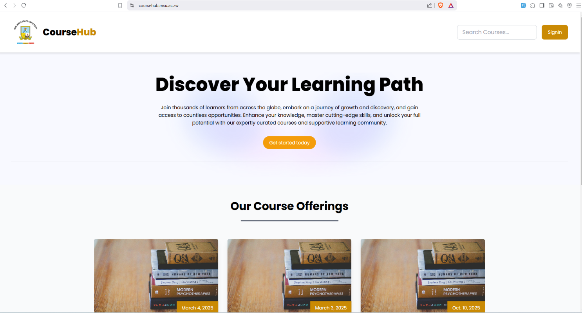

**GOOGLE AUTH LOGIN PAGE**

Link: coursehub.msu.ac.zw/lecturer

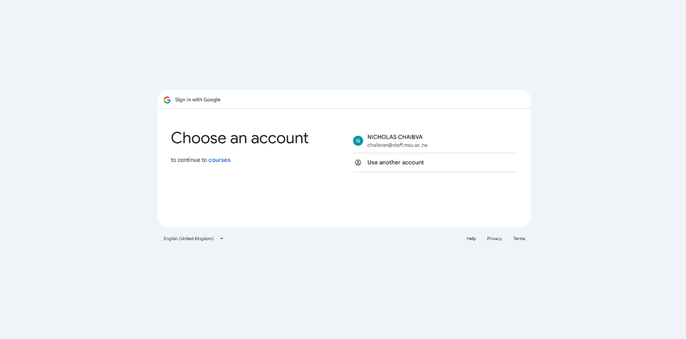

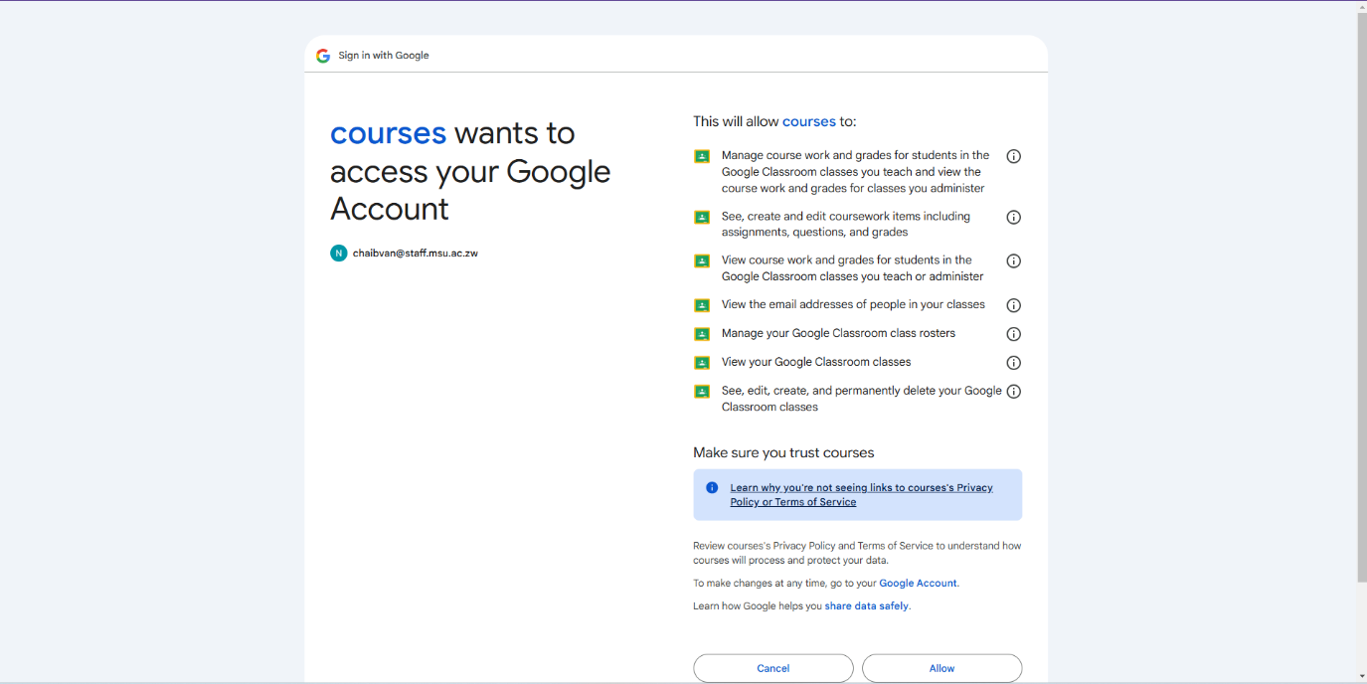

**INSTRUCTOR DASHBOARD**

**Overview**

The instructor dashboard allows instructors to manage courses, create new courses, track student progress, and monitor student activities through Google Classroom integration.

**Instructor Dashboard Features**

1. **View Courses:**
   * Once logged in, the instructor can view all the courses they have created.
   * The list includes the course name, course code, and the number of enrolled students.
   * The instructor can click on any course to access detailed information, including coursework, student submissions, and progress.
2. **Create a New Course:**
   * Instructors can create new courses directly from the dashboard.



**CREATE COURSE**

**Steps to Create a Course:**

* + From the **Instructor Dashboard**, click on the **Create New Course** button.
  + Fill in the required details for the course:
    - **Course Name**: Enter a descriptive name for the course.
    - **Course Description**: Provide a detailed description of the course, outlining the content, learning objectives, and any prerequisites.
    - **Course Code**: This is typically auto generated, but instructors can modify it if needed.
    - **Course Start Date & End Date**: Specify the dates when the course will begin and end.
    - **Instructor Information**: Confirm the instructor’s details (this will be auto filled based on your account information).
  + After entering all the required details, click **Create Course** to save the course. The course will be added to your list of active courses, and you can begin adding coursework and students.

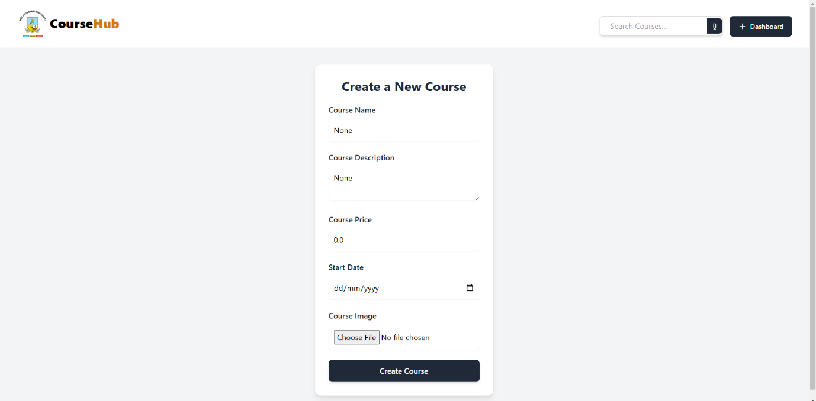

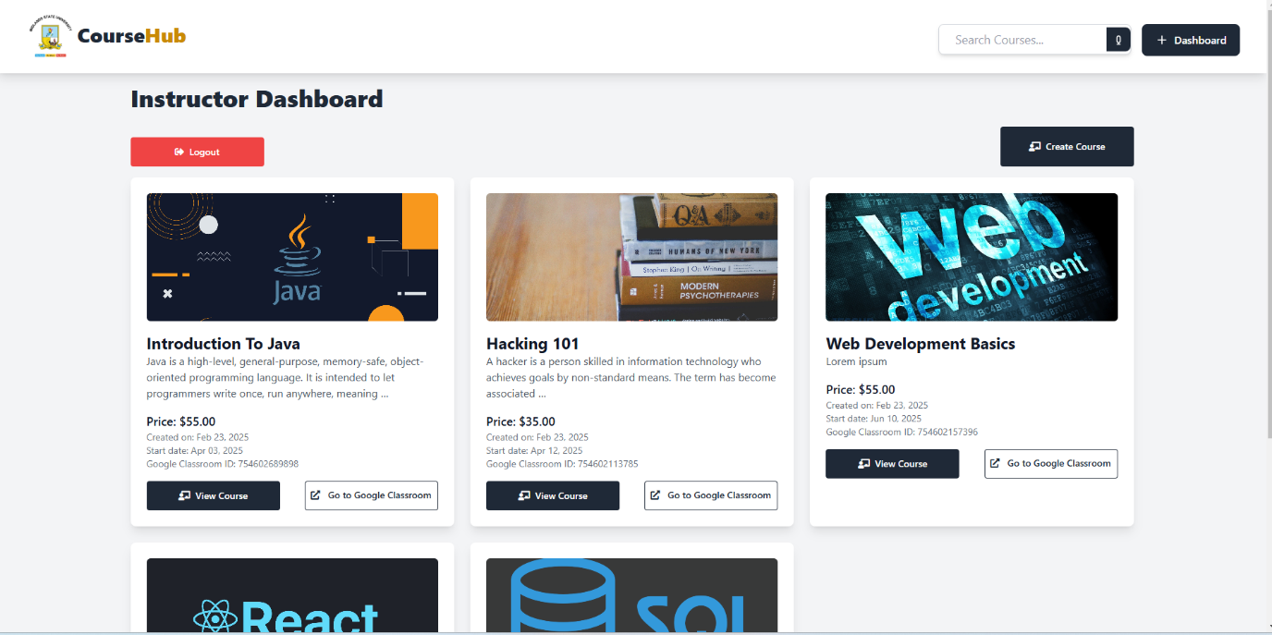

**COURSE DETAILS**

**Access Course Details:**

* Upon selecting a specific course, the instructor can view the following:
* **Coursework**: This will show all assignments and activities for the course.
* **Student Submissions**: The instructor can track which students have submitted their assignments and their grades.
* **Students Enrolled**: The instructor can view the full list of students enrolled in the course.
* **Progress Tracking**: The instructor can track each student's progress, including whether they have completed the coursework or not.

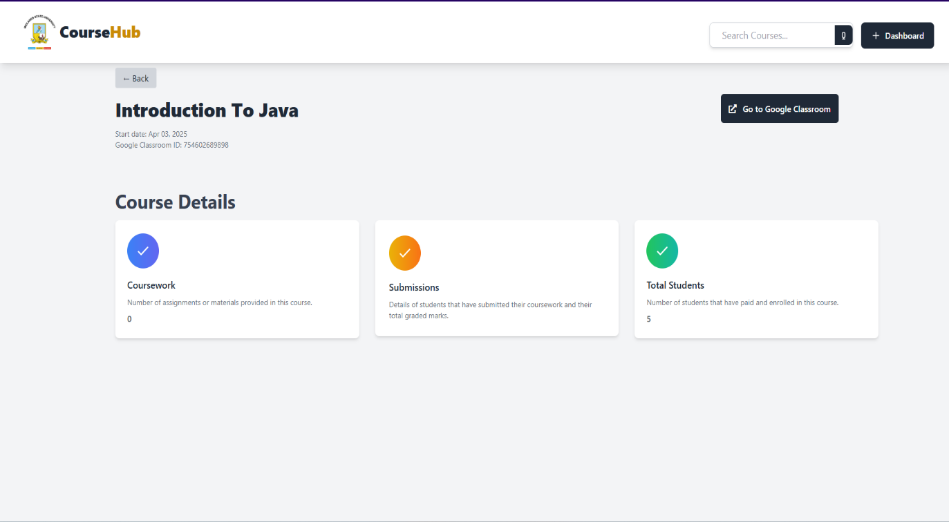

**Track Learner Progress:**

* The instructor can monitor the progress of each student using the Google Classroom API.
* **View Student Submissions**: Check the status of student submissions (e.g., whether they are graded or in-progress).

**COURSE WORK**

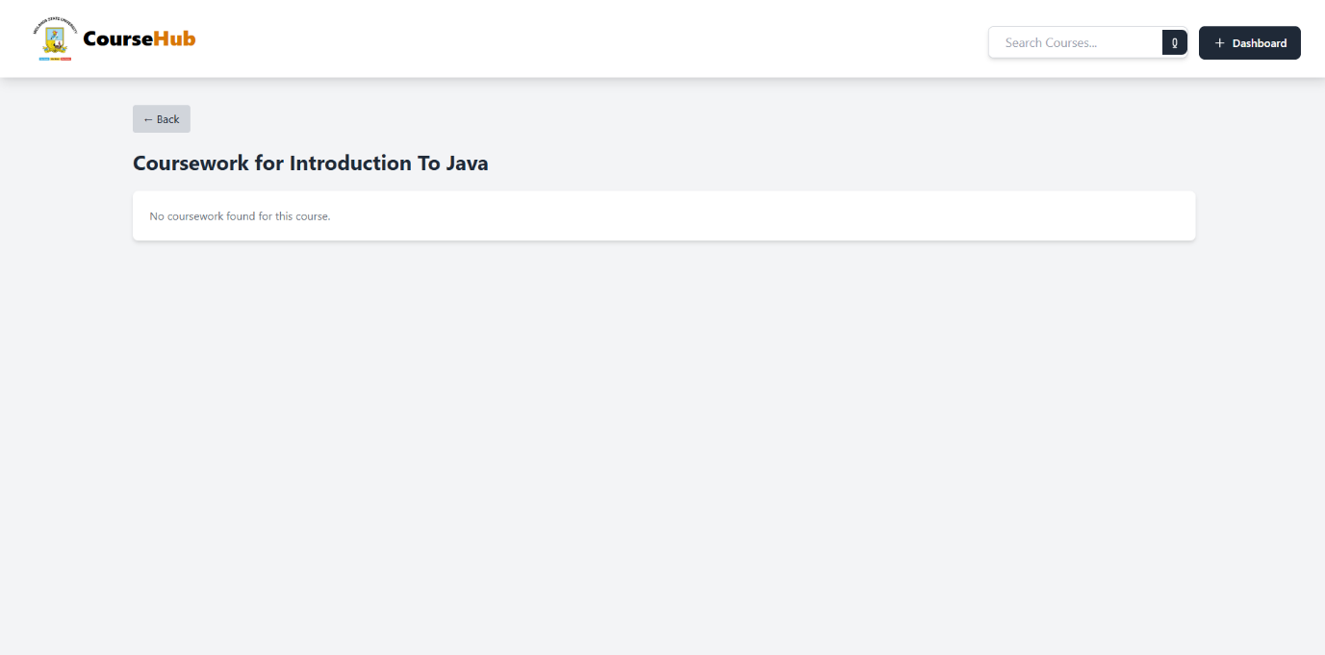

**COURSEWORK SUBMISSIONS**

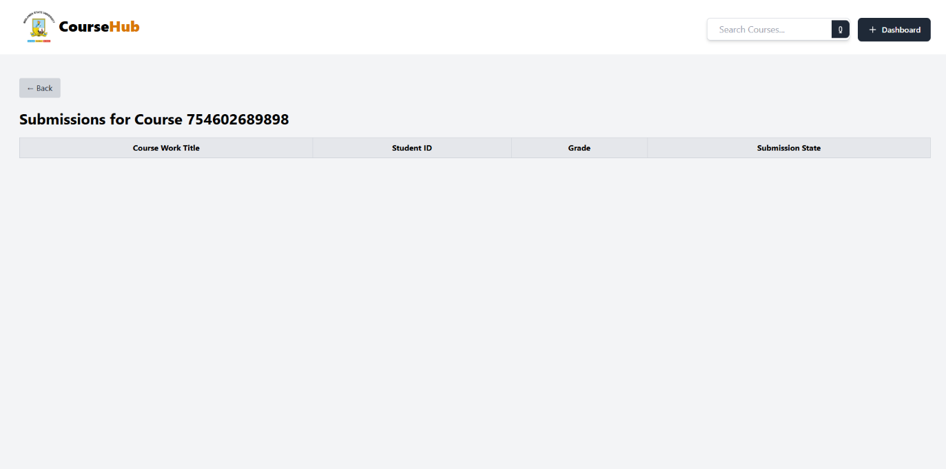

**COURSE STUDENTS**

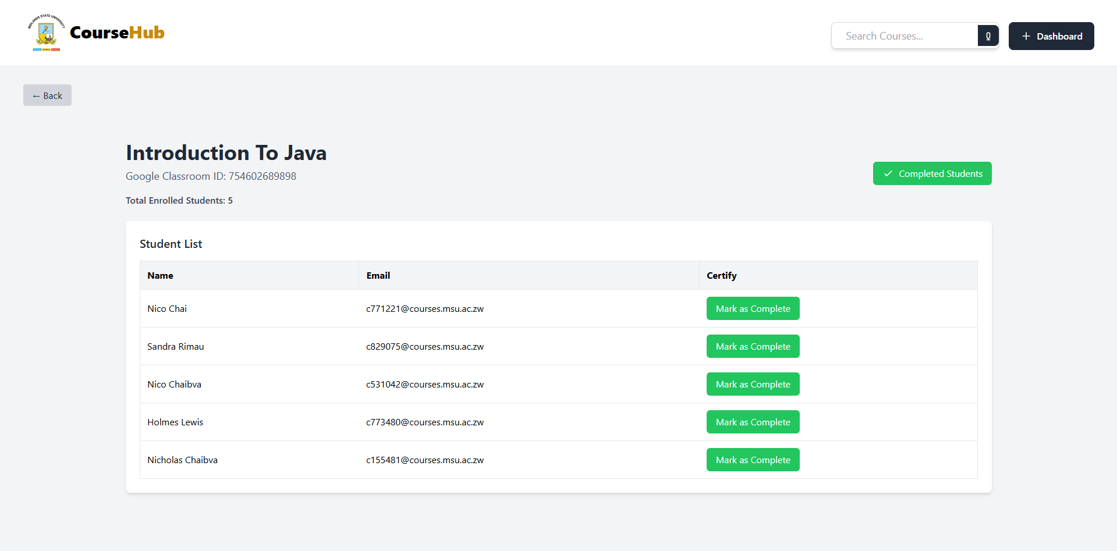

**COMPLETED STUDENTS**

**Mark Student Completion:**

* + The instructor can mark students as "Course Completed" once they finish all the required coursework. This will be visible on the instructor's dashboard.

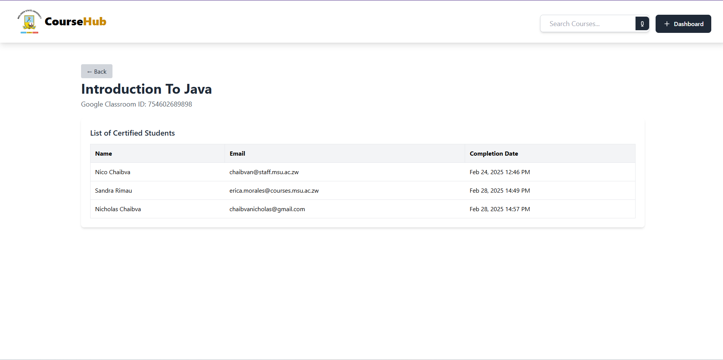

**View Students’ Progress:**

* The instructor can view detailed progress reports for each student:
  + - **Completion Status**: Indicate whether the student has completed the course or not and mark completed students.
    - **Grades**: View grades or feedback submitted for coursework.
    - **Total Submissions**: See how many assignments have been submitted by each student.

This guide provides a view of all **Instructor** functionality within the system. It also outlines all the tools available for instructors to manage their courses, track student progress, and provide feedback.